

A CAPSTONE PROJECT REPORT
Submitted in the partial fulfillment for the award of the degree of
Bachelor Of Engineering In
Computer Science And Engineering
SATELLITE MISSION PLANNING &
GROUND STATION MANAGEMENT SYSTEM
MODULE 2: GROUND STATION & RESOURCE MANAGEMENT
CSA0911 -- Java Programming
Submitted by
A. Vamsi (192372242)
Under the Supervision of
Dr. R. Thalapathi Rajasekaran
SIMATS ENGINEERING
Saveetha Institute of Medical and Technical Sciences
Chennai -- 602105
SEPTEMBER 2026

SIMATS ENGINEERING
Saveetha Institute of Medical and Technical Sciences
Chennai-602105
CERTIFICATE
This is to certify that the Capstone Project entitled "Satellite Mission Planning & Ground Station Management System – Module 2: Ground Station & Resource Management" has been carried out by A. Vamsi (192372242) under the supervision of Dr. R. Thalapathi Rajasekaran and is submitted in partial fulfilment of the requirements for the CSA0911 – Java Programming course in the Bachelor of Engineering in Computer Science and Engineering programme at Saveetha Institute of Medical and Technical Sciences, Chennai.

PROGRAM DIRECTOR | SUPERVISOR
Dr. Sasirekha  Department of IT  Saveetha School of Engineering  SIMATS | Dr. R. Thalapathi Rajasekaran  Department of CSE  Saveetha School of Engineering  SIMATS

INTERNAL EXAMINER | EXTERNAL EXAMINER

SIMATS ENGINEERING
Saveetha Institute of Medical and Technical Sciences
Chennai-602105
DECLARATION
I, A. Vamsi, of the Department of Computer Science and Engineering, SIMATS Engineering, Saveetha Institute of Medical and Technical Sciences, Chennai, hereby declare that the Capstone Project Work entitled "Satellite Mission Planning & Ground Station Management System – Module 2: Ground Station & Resource Management" is the result of my own bonafide efforts. To the best of my knowledge, the work presented herein is original, accurate, and has been carried out in accordance with the principles of engineering ethics and academic integrity. All sources, references, data, and other materials used in the project have been appropriately acknowledged. I further declare that the data, results, analysis, and findings presented in this report have not been fabricated, falsified, or manipulated. Any external tools, software, datasets, computational resources, or AI-assisted tools used during the project have been appropriately disclosed. I confirm that applicable ethical, academic, institutional, and professional requirements have been followed throughout the planning, execution, analysis, and documentation of this module.

Place: Chennai
Date: 26/08/2026
Signature of the Student with Name

INDIVIDUAL CONTRIBUTION STATEMENT
Student Name / Reg. No. | Specific Responsibility | Design & Development | Testing & Analysis | Report Contribution | Contribution (%)
A. Vamsi  (192372242) | Module 2 development: ground-station/resource and conflict-management responsibilities. | Ground-station, scheduling and monitoring-integration work for Module 2. | Conflict-resolution and monitoring validation for Module 2. | Technical documentation for this module report. | 100%
Total Contribution: 100%

ABSTRACT
Satellite missions depend on short and time-sensitive communication opportunities between orbiting spacecraft and ground stations. As the number of satellites and missions increases, several satellites may request the same antenna during overlapping visibility windows, so a dedicated resource-management layer is needed to keep station scheduling conflict-free.
This report documents Module 2: Ground Station & Resource Management, the second module of the larger Satellite Mission Planning & Ground Station Management System. The module accepts candidate Pass records produced by the Mission Planning & Orbit Prediction module (Module 1) and manages ground-station resources against them. It registers ground stations and antennas with their location and capability information, checks station and antenna availability, detects overlapping pass requests, and applies priority-based and/or interval-scheduling logic to resolve conflicts.
The resolved, conflict-free schedule produced by this module becomes the input to the real-time monitoring module (Module 3) that completes the overall system. The module is implemented as part of a three-tier architecture -- React + Vite + TypeScript on the frontend, Java Spring Boot on the backend (station.controller, station.service, scheduling.service and station.repository packages), and PostgreSQL as the persistence layer. This report focuses exclusively on the design, implementation, testing, and results of Module 2.
Keywords: Ground station management, resource scheduling, conflict detection, priority scheduling, interval scheduling, Spring Boot

TABLE OF CONTENTS
Sl. No | Title | Page No
I | CERTIFICATE | II
II | DECLARATION BY THE CANDIDATE | III
III | INDIVIDUAL CONTRIBUTION STATEMENT | IV
IV | ABSTRACT | V
V | LIST OF FIGURES | VI
VI | LIST OF TABLES | VII
VII | LIST OF ABBREVIATIONS | VIII
1 | CHAPTER 1: Introduction
2 | CHAPTER 2: Literature Review
3 | CHAPTER 3: Engineering Design & Trade-offs, Sustainability, Ethics, Safety, Risk & Security
4 | CHAPTER 4: Implementation, Testing & Results, Project Management
5 | CHAPTER 5: Conclusion & Reflection
 | References
 | Appendices

LIST OF FIGURES
Figure No. | Figure Name | Page No.
Figure 1 | Module 2 Architecture (Ground Station & Resource Management)
Figure 2 | Module 2 Workflow — Ground Station & Conflict Resolution
LIST OF TABLES
Table No. | Table Name | Page No.
Table 1 | Functional and Non-Functional Requirements (Module 2)
Table 2 | Core Entities of Module 2
Table 3 | Design Specifications
Table 4 | Technology Stack and Purpose
Table 5 | Test Cases — Module 2
Table 6 | Achievement of Module 2 Objectives
Table 7 | Project Planning — Module 2 Milestones
LIST OF ABBREVIATIONS / SYMBOLS
Symbol | Description | Unit
AOS | Acquisition of Signal | Time
LOS | Loss of Signal | Time
REST | Representational State Transfer | —
JPA | Java Persistence API | —
FCFS | First-Come-First-Served | —

CHAPTER 1: INTRODUCTION AND ENGINEERING PROBLEM
1.1 Background
A ground station can only communicate with one satellite through a given antenna at a time. As the number of registered satellites and missions grows, multiple missions frequently request the same station during overlapping visibility windows. Module 2 of the system is responsible for managing ground-station and antenna resources against the candidate passes produced by Module 1, and for resolving any overlapping requests before a final schedule is handed to the monitoring module.
1.2 Need for the Module
Without a dedicated resource-management layer, overlapping pass requests would have to be resolved manually, which becomes difficult and error-prone as the number of missions and ground stations increases. Module 2 automates the detection of overlapping requests and applies a defined scheduling policy so that ground-station time is allocated consistently and without conflicting bookings.
1.3 Problem Statement
The engineering problem addressed by this module is to manage ground-station and antenna resources -- their availability, capability, and maintenance windows -- and to detect and resolve conflicts when multiple candidate passes compete for the same resource, producing a conflict-free schedule for downstream monitoring.
1.4 Module Aim
To develop the Ground Station & Resource Management module of the Satellite Mission Planning & Ground Station Management System, which registers ground stations and antennas, checks resource availability against candidate passes received from Module 1, detects overlapping requests, and resolves conflicts using priority-based and/or interval-scheduling logic.
1.5 Module Objectives
1. To register ground stations and antennas with location, elevation limits, and capability information.
2. To maintain station/antenna availability and a maintenance calendar.
3. To receive candidate Pass records from Module 1 and check them against resource availability.
4. To detect overlapping pass/resource requests and record them in a ConflictLog.
5. To resolve conflicts using priority-based and/or interval-scheduling logic.
6. To persist the resolved, conflict-free schedule and expose it through REST APIs for the monitoring module.
1.6 Scope
- Ground-station registration with location, elevation limits, and antenna capabilities.
- Resource and antenna allocation, and station availability/maintenance calendar.
- Automatic conflict detection for overlapping candidate passes.
- Priority-based and/or interval-scheduling conflict resolution.
- REST APIs exposing the resolved schedule and conflict records to downstream modules.
Orbit propagation and pass prediction (Module 1) and real-time pass tracking, telemetry, visualization, alerts, and reporting (Module 3) are outside the scope of this module report. The module is intended as an academic capstone implementation; production-grade mission assurance is outside its scope.
1.7 Expected Engineering Outcome
The intended outcome is a working academic prototype of the Ground Station & Resource Management module that reliably converts candidate Pass records into a conflict-free, persisted schedule, forming the link between orbit prediction (Module 1) and real-time monitoring (Module 3) in the overall system.

CHAPTER 2: LITERATURE REVIEW AND EXISTING SOLUTIONS
2.1 Review Method
The references relevant to this module cover research on satellite range scheduling, resource-constrained scheduling, priority-constrained scheduling, visibility conflict optimization, and heuristic/genetic-algorithm-based scheduling. These references were used as the documented research basis for the module's conflict-detection and scheduling concepts.
2.2 Review of Existing Work
The cited literature addresses space-ground communication scheduling, resource constraints, priority constraints, visibility conflicts, and heuristic or genetic-algorithm approaches to satellite range scheduling. Together, these works establish the technical basis for treating ground-station allocation as a time-dependent, resource-constrained scheduling problem, and motivate the use of priority-based and interval-scheduling policies for an academic prototype.
2.3 Comparative Analysis
Existing Approach | Advantages | Limitations in This Context | Relevance to Module 2
Manual / interval-based scheduling | Simple to understand and deterministic for small cases. | Becomes difficult when many passes and resource constraints overlap. | Used as the basis for conflict detection and interval scheduling.
Priority-based scheduling | Provides a direct policy for resolving competing requests. | May not optimize overall mission value or station utilization. | Used to retain higher-priority requests in documented conflicts.
Heuristic / genetic scheduling | Can address larger, more complex scheduling spaces. | Adds algorithmic complexity beyond the academic prototype. | Identified in literature as a possible future enhancement.
2.4 Research / Engineering Gap
Much of the existing literature treats scheduling as an isolated optimization problem rather than as a module that must consume live candidate passes from an upstream prediction service and hand off a resolved schedule to a downstream monitoring service. The engineering gap addressed by Module 2 is the integration of resource-availability checking, conflict detection, and priority/interval scheduling into one data pipeline that sits between orbit prediction and monitoring.
2.5 Proposed Contribution
Module 2 contributes a Java-based ground-station resource-management service in which candidate Pass records are checked against station and antenna availability, overlapping requests are detected and logged, and priority-based/interval-scheduling logic resolves conflicts. The resulting schedule is persisted in PostgreSQL and exposed through REST APIs, forming the link between the orbit-prediction module and the monitoring module that completes the overall system.

CHAPTER 3: ENGINEERING DESIGN & TRADE-OFFS, SUSTAINABILITY, ETHICS, SAFETY, RISK & SECURITY
3.1 Requirements
Stakeholder / User Requirements
Stakeholder | Requirement
Ground-station operators | Manage station/antenna resources and view conflicts.
Mission / operations managers | Review priorities, conflicts, and resolved schedules.
Mission Planning module (upstream) | Supply candidate Pass records for scheduling.
Monitoring module (downstream) | Receive a conflict-free, resolved schedule.
System administrators | Maintain station, antenna, and availability data.
Functional & Non-Functional Requirements (Table 1)
Requirement | Type | Measurable Target
Register ground stations and antenna capabilities. | Functional | Station/resource records available for scheduling.
Maintain station/antenna availability and maintenance calendar. | Functional | Availability records reflect booked and free slots.
Receive candidate Pass records from Module 1. | Functional | Candidate passes checked against resource availability.
Detect overlapping pass/resource requests. | Functional | ConflictLog created for overlapping requests.
Resolve conflicts using priority and interval scheduling. | Functional | Non-conflicting schedule produced according to policy.
Expose resolved schedule via REST APIs. | Functional | Downstream monitoring module can query the current schedule.
Modularity and maintainability. | Non-Functional | Controller/service/repository separation maintained.
3.2 Constraints & Applicable Standards
The source project does not identify a specific external technical standard or regulatory code for this module. The documented engineering constraints are recorded below.
Constraint / Practice | Requirement | How Applied in Module 2
Resource availability | Schedules must respect station/antenna availability. | Check availability before booking a candidate pass.
Database consistency | Conflicting bookings should not be created concurrently. | Use database transactions around conflict detection and booking updates.
Time consistency | Timestamps must remain consistent across database and backend. | Use consistent time handling for booking intervals.
Security | Schedule modifications require controlled access. | Use server-side authorization for booking/conflict-resolution endpoints.
3.3 Design Specifications (Table 3)
Parameter | Target / Requirement | Unit | Priority
Ground-station data | Latitude, longitude, altitude, elevation limits | Geographic | High
Antenna data | Frequency band, capability | Record | High
Resource scheduling | No conflicting bookings for the same resource | Interval | High
Conflict detection | Overlapping requests logged as ConflictLog entries | Record | High
Persistence | Shared PostgreSQL database | Database | High
API exposure | REST endpoints for station/schedule/conflict data | Endpoint | High
3.4 Alternative Solutions & Evaluation
Alternative 1: First-come-first-served (FCFS) booking, where the earliest-submitted candidate pass for a resource is always accepted and later overlapping requests are simply rejected. This is simple to implement but does not account for mission priority, so a high-priority mission could be rejected in favour of a lower-priority one submitted earlier.
Alternative 2: Priority-based and interval-scheduling conflict resolution, where overlapping requests are detected by interval-overlap checks and resolved by retaining the higher-priority mission (or applying interval-scheduling rules when priorities are equal). This matches the documented project requirement to favour mission priority and is the approach selected.
Criterion | Weight | Alternative 1 (FCFS) | Alternative 2 (Priority/Interval, selected)
Fairness to mission priority | High | Ignores mission priority | Explicitly considers priority
Implementation complexity | Medium | Simple | Moderate -- interval-overlap and priority logic
Resource utilization | Medium | Can leave gaps from rejected requests | Better matches resources to priority missions
Consistency | High | Order-dependent outcomes | Deterministic given priority and interval rules
3.5 Selected Design & Detailed Design
Module 2 is implemented as a set of Spring Boot packages -- station.controller, station.service, scheduling.service, and station.repository -- backed by the shared PostgreSQL database. The controller layer exposes REST endpoints for station/antenna registration and for submitting candidate passes for scheduling. The service layer checks station and antenna availability, detects overlapping requests using interval-overlap checks, records conflicts in a ConflictLog, and applies priority-based/interval-scheduling rules to produce a resolved schedule. The repository layer persists GroundStation, Antenna, Availability, and ConflictLog entities.
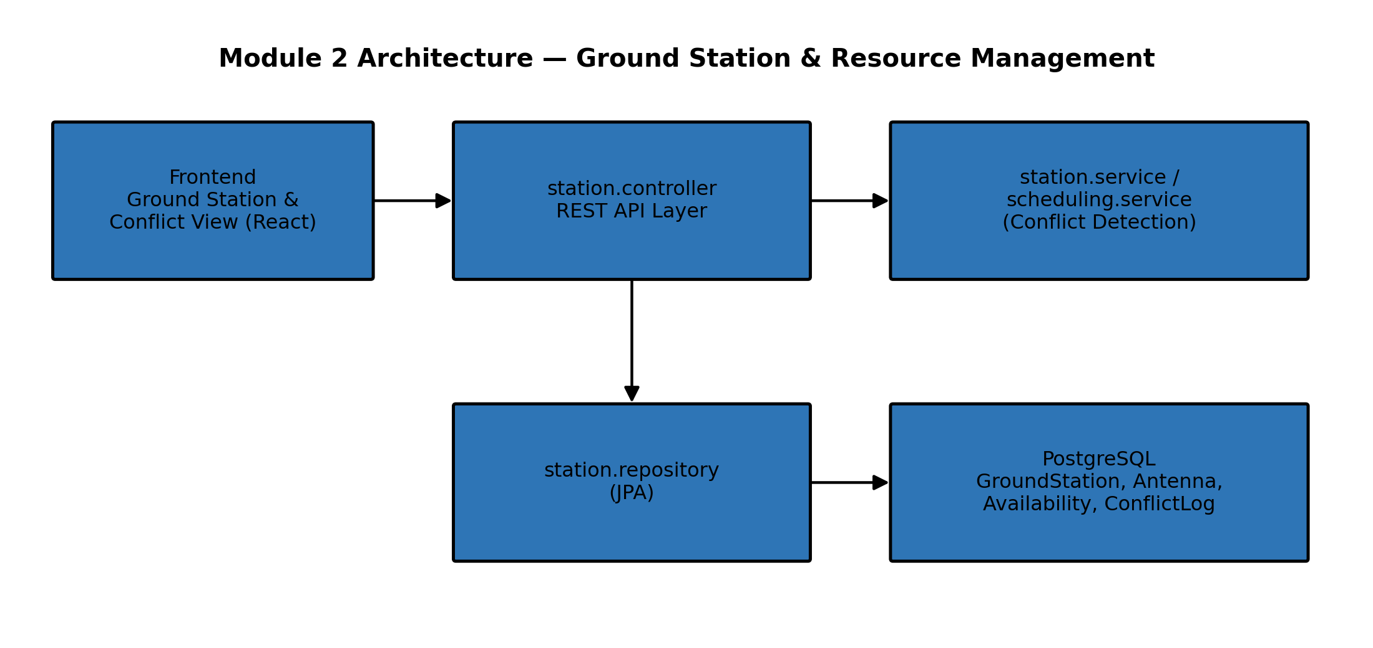
Figure 1. Module 2 Architecture (Ground Station & Resource Management)
Core Entities of Module 2 (Table 2)
Entity | Stored Information
GroundStation | Location, elevation limits.
Antenna | Frequency band, capability; linked to a GroundStation.
Availability | Booked and free time slots.
ConflictLog | Detected overlaps and their resolution.
3.6 Sustainability, Ethics, Health & Safety, and Security
Area | Consideration | Applied in Module 2 | Outcome
Sustainability | Avoid unnecessary deployment complexity for the academic prototype. | Scheduling logic embedded in the shared Spring Boot backend rather than a separate service. | Fewer deployment components.
Ethics | Academic integrity, accurate reporting. | Declaration and reference list document all external resources used. | No fabricated or manipulated results are claimed.
Health & Safety | Avoid treating the prototype as operational spacecraft-control software. | Module output is a scheduling aid; safety-critical command uplink is explicitly out of scope. | System scope limited to academic planning.
Security | Protect schedule and resource data from unauthorized modification. | Server-side authorization documented for booking/conflict-resolution endpoints. | Security controls included as engineering requirements.
Risk Register
Risk | Likelihood | Severity | Risk Level | Mitigation
Conflicting bookings created concurrently | Medium | High | High | Use interval-overlap checks and database transactions.
Incorrect priority resolution | Low | High | Medium | Apply documented priority policy consistently and test with mixed-priority scenarios.
Maintenance-window overlap missed | Medium | Medium | Medium | Check maintenance calendar before confirming a booking.

CHAPTER 4: IMPLEMENTATION, TESTING & RESULTS, PROJECT MANAGEMENT
4.1 Development Approach & Resources
Module 2 is developed within the shared Spring Boot backend, organized into module-aligned packages rather than a separate application. PostgreSQL provides the persistence layer for ground-station, antenna, availability, and conflict data, while REST APIs handle registration, scheduling, and conflict-query operations.
Resource | Purpose
Java + Spring Boot | station.controller, station.service, scheduling.service business logic.
PostgreSQL + JPA/Hibernate | Persistent GroundStation, Antenna, Availability and ConflictLog records.
Maven | Backend build and dependency management.
4.2 Software Implementation & Tools Used
Tool / Software | Purpose | Stage Used
Java / Spring Boot | REST controllers, services and scheduling/conflict-detection logic for Module 2. | Implementation
PostgreSQL / JPA / Hibernate | Persistent data model for stations, antennas, availability and conflicts. | Implementation
Maven | Dependency and build management. | Build / Deployment
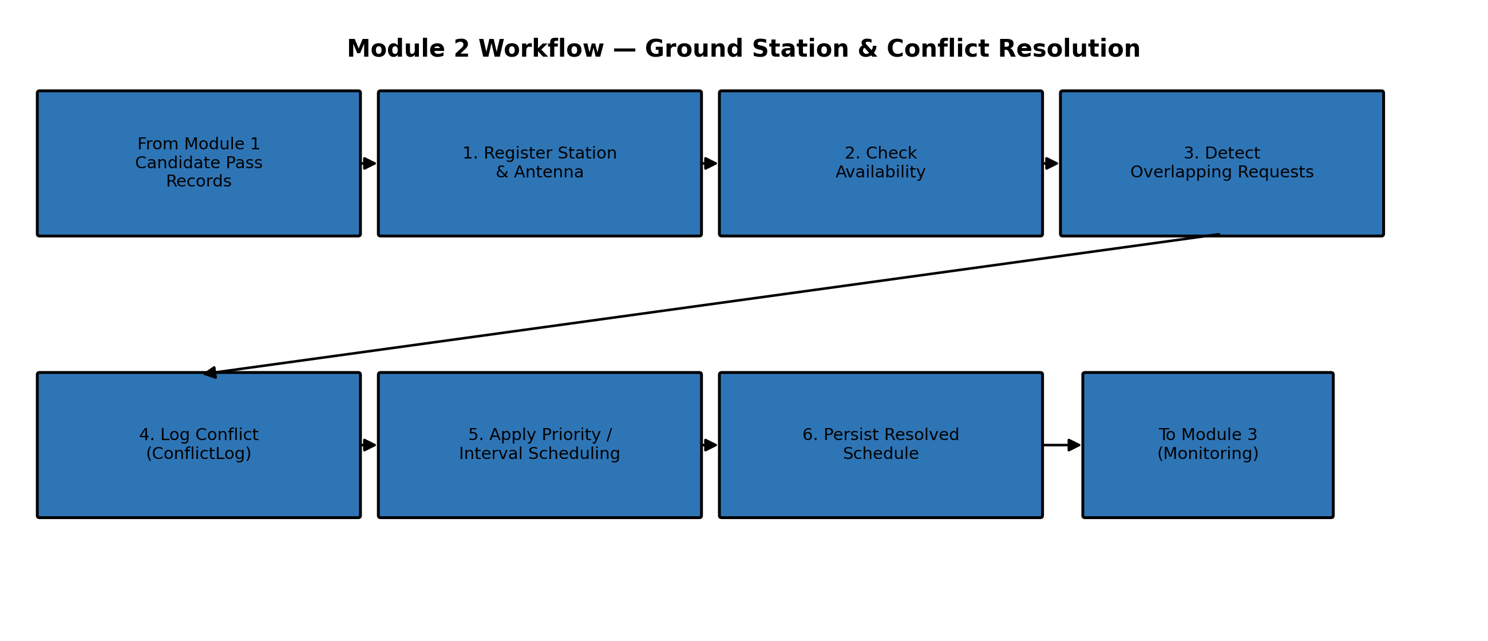
Figure 2. Module 2 Workflow — Ground Station & Conflict Resolution
4.3 Test Plan & Verification (Table 5)
Requirement | Test Method | Acceptance Criterion
Station/antenna registration | Register a ground station and its antennas. | Station and antenna records stored with capability information.
Availability check | Submit a candidate pass against a station's availability. | Booking accepted only if the resource is free.
Conflict detection | Submit overlapping pass requests for the same resource. | ConflictLog entry is created.
Conflict resolution | Use conflicting missions with different priorities. | Higher-priority mission is retained according to policy.
Maintenance constraint | Overlap a pass with station maintenance. | Booking is rejected or moved.
Schedule persistence | Query the resolved schedule after conflict resolution. | Persisted schedule matches the resolution outcome.
4.4 Results
The intended result of Module 2 is a reliable pipeline in which candidate Pass records from Module 1 are checked against ground-station and antenna resources, overlapping requests are detected and resolved, and a conflict-free schedule is persisted for the monitoring module to consume.
Result Area | Documented Result
Ground-station management | Availability and booking state for registered stations/antennas.
Conflict management | Conflict records and documented resolution actions.
Scheduling | Resolved, conflict-free schedule available to the monitoring module.
API exposure | REST endpoints return current station, schedule and conflict data.
4.5 Data Analysis & Engineering Judgment
Scheduling performance depends on the number of candidate passes and resources under consideration. A practical implementation should first filter candidate passes by station and time interval, then apply conflict detection only to relevant overlapping windows, rather than comparing every candidate pass against every other one. Database transactions around the availability-check-and-book sequence prevent two overlapping bookings from being confirmed concurrently.
4.6 Achievement of Objectives (Table 6)
Objective | Evidence | Achievement
Ground-station/resource management | Station, antenna and availability entities and services documented. | Fully demonstrated at prototype level
Conflict detection | Overlap check and ConflictLog documented. | Fully demonstrated at prototype level
Conflict resolution | Priority/interval scheduling logic documented. | Fully demonstrated at prototype level
Schedule persistence and API exposure | station.controller endpoints and repository documented. | Fully demonstrated at prototype level
4.7 Strengths & Limitations
Strengths
- Applies deterministic conflict detection using interval-overlap checks.
- Uses a documented priority-based/interval-scheduling policy for resolution.
- Checks maintenance windows before confirming a booking.
- Clean package separation (controller/service/repository) supports maintainability.
Limitations
- Advanced optimization objectives (for example, maximizing overall station utilization) are not implemented in the documented prototype.
- Scheduling depends on the accuracy of the candidate Pass records supplied by Module 1.
- Live tracking and monitoring of the resolved schedule are handled by Module 3, not this one.
4.8 Project Planning & Milestones (Table 7)
Milestone | Work Package | Outcome
1 | Requirement and problem analysis | Problem statement, objectives and scope for Module 2.
2 | Data design | GroundStation, Antenna, Availability and ConflictLog entity design.
3 | Ground-station CRUD | Station/antenna registration and availability management.
4 | Conflict detection & resolution algorithm | Interval-overlap checks and priority/interval scheduling logic.
5 | Testing and validation | Functional test cases and conflict scenarios.
6 | Documentation | Module 2 capstone report.

CHAPTER 5: CONCLUSION, FUTURE WORK AND REFLECTION
5.1 Conclusion
Module 2: Ground Station & Resource Management addresses the central resource-allocation problem of the Satellite Mission Planning & Ground Station Management System -- converting candidate visibility windows into a conflict-free ground-station schedule. Using interval-overlap checks and priority-based/interval-scheduling logic, the module registers ground stations and antennas, checks resource availability, detects overlapping requests, and resolves conflicts.
Implemented within the shared three-tier architecture -- React frontend, Spring Boot backend, and PostgreSQL database -- Module 2 keeps its resource-management and scheduling logic in clearly separated station.controller, station.service, scheduling.service and station.repository packages, and exposes its output through REST APIs. This module consumes the Pass records produced by the orbit-prediction module (Module 1) and produces the resolved schedule consumed by the monitoring module (Module 3), though the design and implementation of those modules fall outside the scope of this report.
The main contribution of this module is therefore a reliable, deterministic conflict-detection and resolution service that converts competing resource requests into a consistent, persistable ground-station schedule.
5.2 Future Work
- Add more advanced scheduling objectives such as maximizing mission value or overall station utilization.
- Support multiple antennas and simultaneous frequency-band constraints per station.
- Add authentication, role-based access and audit trails for schedule modifications.
- Add automated integration tests for the full conflict-detection and resolution flow.
- Add email/mobile notifications for rejected or rescheduled bookings.
5.3 Professional Learning & Individual Reflection
New Knowledge Acquired
- Ground-station resource modelling and availability management.
- Conflict detection and interval-scheduling concepts.
- Java Spring Boot, REST APIs and JPA/Hibernate.
Engineering & Professional Skills Developed
- Designing deterministic conflict-resolution logic under resource constraints.
- Database modelling and transaction-aware scheduling.
- Testing, debugging and technical documentation.
Individual Reflection — A. Vamsi
Developing Module 2 provided practical exposure to the relationship between ground-station resource management, scheduling conflicts, and the modules that depend on its output. Working with the integrated workflow highlighted the importance of consistent interfaces between modules, particularly the need to trust and correctly interpret the candidate Pass records supplied by Module 1. The experience strengthened problem-solving, transaction-aware database design, testing and technical documentation skills.
5.4 Overall Reflection
Overall, working on this module improved confidence in designing a resource-management and conflict-resolution service that sits correctly between two other modules in a larger full-stack system. It combined algorithmic scheduling with Java backend engineering and relational data management, and reinforced the importance of documenting assumptions and validating the interface between this module and the rest of the system.

REFERENCES
[1] L. Barbulescu, J.-P. Watson, L. D. Whitley, and A. E. Howe, "Scheduling Space--Ground Communications for the Air Force Satellite Control Network," Journal of Scheduling, vol. 7, pp. 7-34, 2004.
[2] F. Marinelli, S. Nocella, F. Rossi, and S. Smriglio, "A Lagrangian heuristic for satellite range scheduling with resource constraints," Computers & Operations Research, vol. 38, no. 11, pp. 1572-1583, 2011.
[3] B. Sun, "Satellite mission scheduling based on genetic algorithm," Kybernetes, vol. 39, no. 8, pp. 1255-1261, 2010.
[4] L. Yuqing, R. Wang, and M. Xu, "Satellite range scheduling with the priority constraint: An improved genetic algorithm using a station ID encoding method," Chinese Journal of Aeronautics, vol. 28, no. 3, pp. 789-803, 2015.
[5] K. Luo et al., "High-performance technique for satellite range scheduling," Computers & Operations Research, vol. 85, pp. 12-21, 2017.
[6] S. Spangelo, J. Cutler, and K. Gilson, "Optimization-based scheduling for the single-satellite, multi-ground station communication problem," Computers & Operations Research, vol. 57, pp. 1-16, 2015.
[7] A. S. Eshetu and H.-D. Kim, "A New Strategy of Visibility Conflict Optimization Between Multiple Ground Stations and Satellites," International Journal of Aeronautical and Space Sciences, vol. 23, no. 5, pp. 1009-1020, 2022.
[8] X. Xu et al., "A Hybrid Genetic Algorithm for Ground Station Scheduling Problems," Applied Sciences, vol. 14, no. 12, 5045, 2024.

APPENDICES
Appendix A — Module 2 Detailed Workflow
1. Receive candidate Pass records from Module 1.
2. Register ground station and antenna resources (if not already registered).
3. Check station/antenna availability for each candidate pass.
4. Detect overlapping requests among candidate passes for the same resource.
5. Log detected overlaps in ConflictLog.
6. Apply priority-based and/or interval-scheduling rules to resolve conflicts.
7. Persist the resolved schedule and conflict log.
8. Expose the resolved schedule via REST APIs for the monitoring service (Module 3).
Appendix B — Module 2 Core Entities
Entity | Stored Information
GroundStation | Location, elevation limits.
Antenna | Frequency band, capability.
Availability | Booked & free time slots.
ConflictLog | Detected overlaps, resolution.
Appendix C — Suggested API / Data Flow
A representative Module 2 request sequence is: GET candidate passes (from Module 1) → POST station/antenna → POST schedule request → GET conflicts/resolution. The GET conflicts/resolution response becomes the input to the monitoring module (Module 3).
Appendix D — Suggested Database Relationships
- GroundStation 1:N Antenna
- GroundStation 1:N Availability
- Pass N:1 GroundStation
- GroundStation/Pass data contribute to conflict resolution
Appendix E — Project Module Mapping
This report documents Module 2 in detail. For context, the complete system also includes Module 1 (Mission Planning & Orbit Prediction) and Module 3 (Communication, Data & Monitoring), documented separately.
Module | Primary Backend Packages | Primary Frontend View
Module 2 (this report) | station.controller / station.service / scheduling.service / station.repository | Ground Station & Conflict Management

